Net 1061 Switching, Routing, and Wireless Essentials

Name:

Lab: #

Follow the instructions down below for the lab itself. For this lab, all answers need to be in blue font. For the questions right below, answer in complete sentences. If this is a self-grading packet tracer. Ensure you paste the screen shot of your score page at the bottom of the document. You will upload both this document and the pkt file regardless if it is self-grading or not. Let the instructor know if you have any questions.

Lab Analysis Report

1. Using complete sentences summarize work you completed during the lab.
In this lab I observed how spanning tree works. I pinged PC2 first, then used the show spanning-tree command on all the switches to see what each port status was. Then I removed one cable and observed the change. Finally I made another ping.

2. Using complete sentences describe what you learned from the lab. Hint; look at the lab objectives listed at the top of the lab section.
In this lab I learned how spanning-tree works in a network. I learned how the different port status works and how the status changes when a connection fails.

Problems Encountered

1. Using complete sentences describe any problem(s) experienced during lab.
I didn’t experience any problems.

2. Using complete sentences describe how you solved your problem(s).

3. Using complete sentences explain if you needed any assistance with the lab; then list what you learned from that assistance.

Packet Tracer - Investigate STP Loop Prevention

Objectives
In this lab, you will observe spanning-tree port states and watch the spanning-tree convergence process.
- Describe the operation of Spanning Tree Protocol.
- Explain how Spanning Tree Protocol prevents switching loops while allowing redundancy in switched networks.

Background / Scenario
In this activity you will use Packet Tracer to observe the operation of Spanning Tree Protocol in a simple switched network that has redundant paths.

Instructions

Observe a Converged Spanning-Tree Instance

Verify Connectivity.
Ping from PC1 to PC2 to verify connectivity between the hosts. Your ping should be successful.

View spanning-tree status on each switch.
Use the show spanning-tree vlan 1 command to gather information about the spanning tree status of each switch. Complete the table. For the purposes of the activity, only consider information about the Gigabit trunk ports. The Fast Ethernet ports are access ports that have end devices connected and are not part of the inter-switch trunk-based spanning tree.
Open configuration window
Switch | Port | Status (FWD, BLK…) | Root Bridge?
S1 | G0/1 | FWD | blankDesignated
S1 | G0/2 | FWD | Root
S2 | G0/1 | FWDblank | Designated
S2 | G0/2 | FWDk | Designated
S3 | G0/1 | FWD | Rootblank
S3 | G0/2 | BLKblank | Alternate
Packet Tracer uses a different link light on one of the connections between the switches.

Questions:
What do you think this this link light means?
That it is in blocking mode.Type your answers here.
What path will frames take from PC1 to PC2?
PC1 – S1 – S2 – PC2 Type your answers here.
Why do the frames not travel through S3?
The connection from S1 to S3 is blocked.
Type your answers here.
Why has spanning tree placed a port in blocking state?
To avoid a loop.Type your answers here.
Close configuration window

Observe spanning-tree convergence

Remove the connection between S1 and S2.
      - Open a CLI window on switch S3 and issue the command show spanning-tree vlan 1. Leave the CLI window open.
Open configuration window
      - Select the delete tool from the menu bar and click the cable that connects S1 and S2.

Observe spanning-tree convergence.
      - Quickly return to the CLI prompt on switch S3 and issue the show spanning-tree vlan 1 command.
      - Use the up-arrow key to recall the show spanning-tree vlan 1 command and issue it repeatedly until the orange link light on the cable turns green. Observe the status of port G0/2.

Question:
What do you see happen to the status of the G0/2 port during this process?
It changed to LSN.your answers here.
You have observed the transition in port status that occurs as a spanning-tree port moves from blocking to forwarding state.
      - Verify Connectivity by pinging from PC1 to PC2. Your ping should be successful.
Are any ports showing an orange link light that indicates that the port is in a spanning-tree state other than forwarding? Why or why not?
No, because there is a straight path from PC1 to PC2 with no redundant cables.Ty
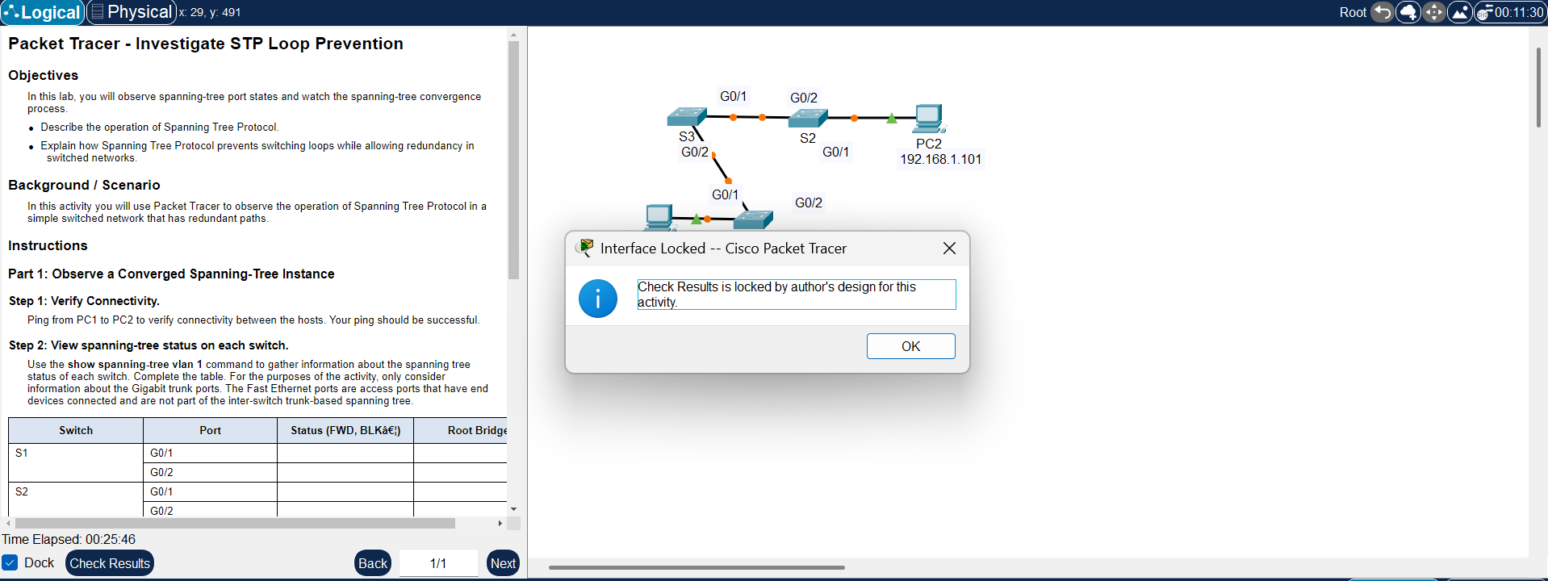
Close configuration window
End of document

